TASK 1

1. Change usage location

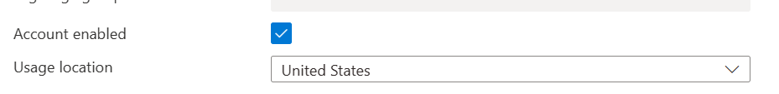

1. Create a new user

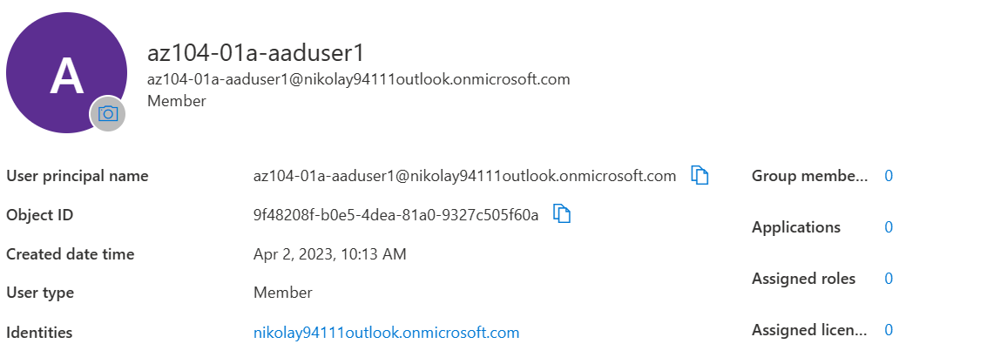

1. Assigned new roles

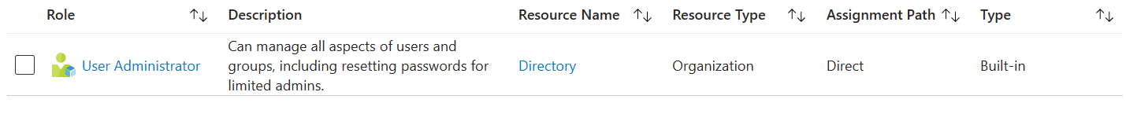

1. Create a new user from new user before

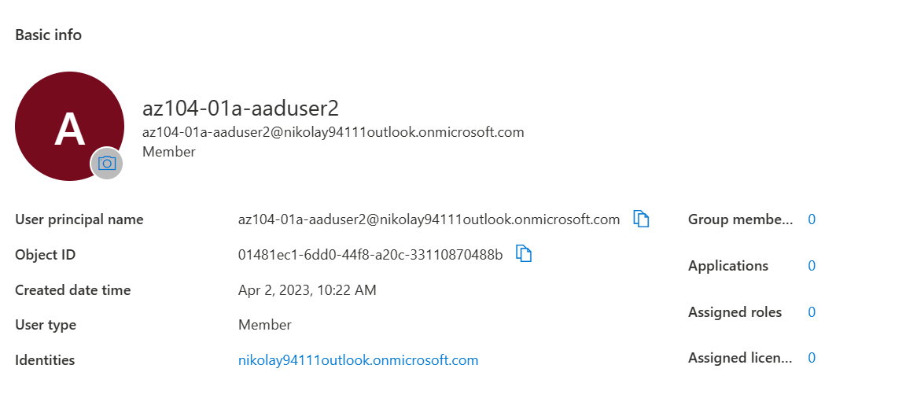

TASK 2

1. Add premium license



2. Assign licenses to two new created users

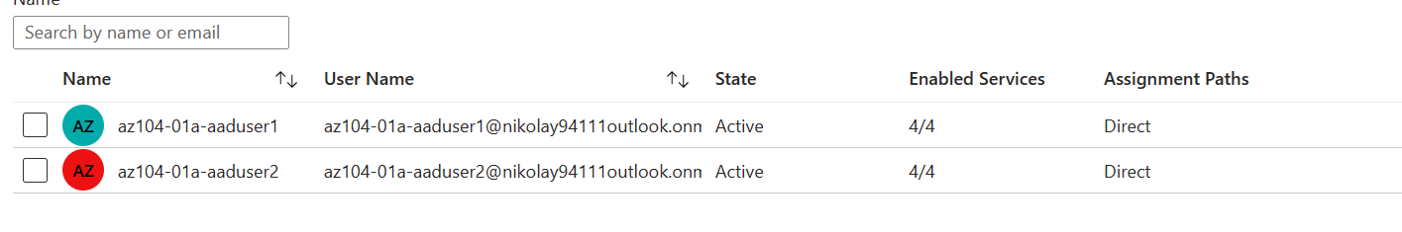

3. Create new groups

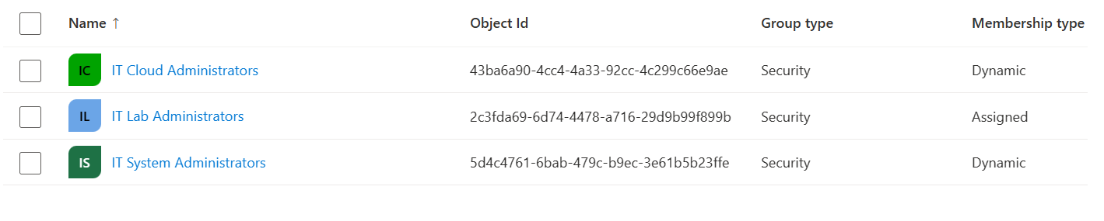

1. Members in each group

